Social Reconstruction

Social reconstruction is actually a belief that education should be used to bring change in society. It emphasizes the addressing of social questions and a quest to create a better society and worldwide democracy.
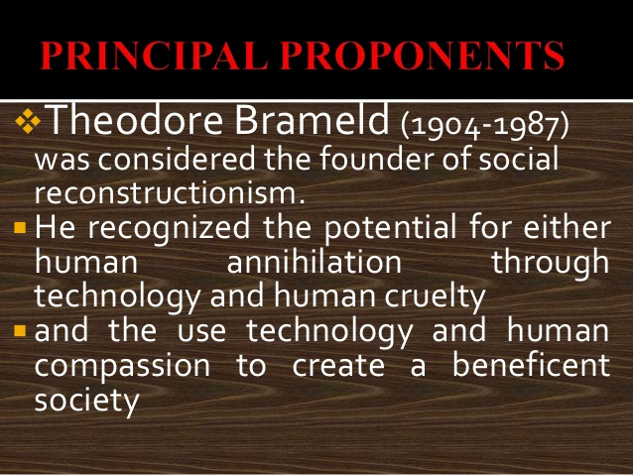

Theodore Burghard Hurt Brameld (1904-1987) was a leading educational philosopher of the 20th century. As an American educator and educational philosopher, Brameld was best known as the founder of Social Reconstructionism.

Background:
The idea of social-reconstructionist education was based on a 19th-century belief in the power of education to change society. In the last quarter of the 20th century there was considerable pessimism, but the idea that schooling could influence either society or the individual was widely held, affecting the growth of tertiary-level alternatives, management strategies, and education of disadvantaged people, in both industrialized and developing countries.
- Origin of social reconstruction is United States of America
- In 1880s and 1890s, Lester Frank Ward began the discussion of social reconstruction with the publication of Dynamic Sociology(1883) and The psychics Factors of civilization.
- In 1948, John Dewey prepared the way of social reconstruction.
- In 1950, Theodore Brameld wrote a book which advocated the social reconstruction ideology.

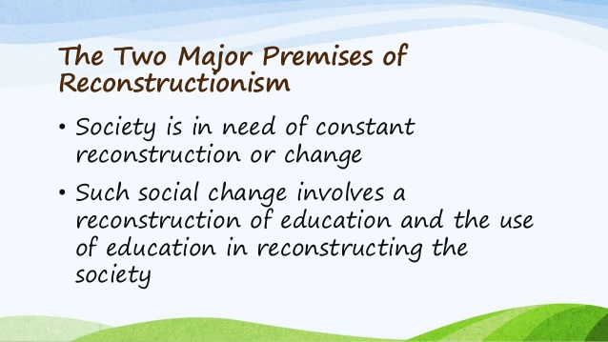
Goal:
To transform our society into a more just society.
- Social Reconstruction is itself a Theory.
- Social Reconstructionists view learning from the perspective of constructivism's.

Aims of Social Reconstructionism:
- To eliminate from their culture those aspects they believe undesirable,to substitute in their place social practices and values they believe more desirable.
- To educate the youth so that they can reconstruct their current society and live in a society superior to the existing one.
- To redirect the growth of their society to reconstruct it into a more just, satisfying, democratic and humane society (Schiro, 2013)

Reconstructionists not only aim to educate a generation of problem solvers, but also try to identify and correct many noteworthy social problems that face our nation, with diverse targets including racism, pollution, homelessness, poverty, and violence. Rather than a philosophy of education, reconstructionism may be referred to as more of a remedy for a society that seeks to build a more objective social order.

The reconstructionist classroom contains a teacher who involves the students in discussions of moral dilemmas to understand the implications of one’s actions. Students individually select their objectives and social priorities and then, with guidance from the teacher, create a plan of action to make the change happen.

Problems:
Social Reconstructionists begin with the assumption that the survival of our society is threatened by many problems.
- Racism
- War
- Poverty
- Pollution
- Energy shortage
- Illiteracy
- Inadequate health care
- Unemployment

Role of Teachers:
- Lead the learners in designing programs for social, educational, practical, and economic change.
- Primary agent of social change.
- Initiates lively discussions on controversial issues – political and educational.
- Enables the learners to critically examine their cultural heritage.
- Facilitate process of students identifying and solving community-based problems.

Teaching method:
- Cooperative learning
- Discussion method
- Group problem solving
- Encourage students to use problem solving skills.

Key Points:
based on early socialistic and utopian ideas of the 19th century.
It is society-centered philosophy.
Exponents: Theodore Brameld is often considered the originator of the term reconstructionism in 1950.
Concept: crisis philosophy appropriate for a society in crisis
Reconstructionism and Education: The reconstructionists seek a curriculum that emphasizes cultural pluralism, equality and futurism.
Reconstructionist educators focus on a curriculum that highlights social reform as the aim of education.

Vision of future Good society:
